**UCS 2312 Data Structures Lab**

**Assignment 10: Implementation of Shortest Path Finding algorithm**

**Date of Assignment: 18.11.2023**

The cityADT contains the number of cities and the connectivity information between the cities (adjacency matrix). Write the following methods. [CO2, K3]

* void create(cityADT *C) – will represent the graph using adjacency matrix
* void disp(cityADT *C) – Display the graph
* void Dijkstra(cityADT *C) – Displays the intermediate and final tables
* char * displayPath(cityADT *C, source, destination) – Find the path of the intermediate cities between the source and destination cities along with the cost

**Data Structure – Graph:**

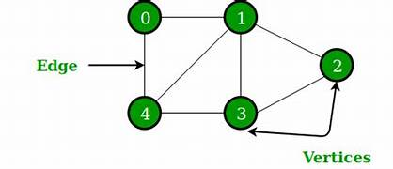

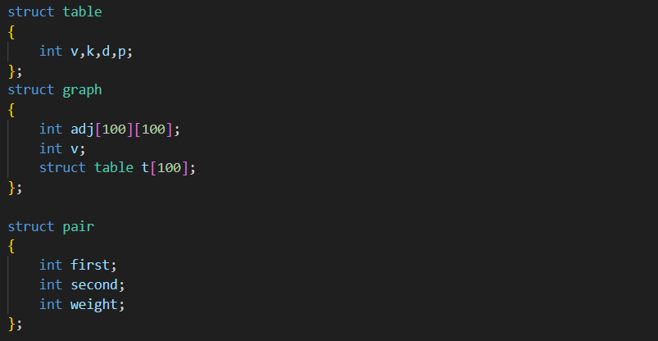

**Algorithm –**

**Algorithm: will create the graph using adjacency matrix**

Input – Pointer to Graph, no. of vertices, no. of edges, array of pairs

Output – void

1. G->v=v
2. for(i=0;i<e;i++)

if directed graph

G->adj[pairs[i].first][pairs[i].second]=1

else

G->adj[pairs[i].first][pairs[i].second]=1

G->adj[pairs[i].second][pairs[i].first]=1

**Algorithm: display the adjacency matrix**

Input – Pointer to Graph

Output – void

1. i=1 and j=1
2. while(i<=G->v)

while(j<=G->v)

print G->adj[i][j]

print a new line

**Algorithm: Displays the intermediate and final tables**

Input – Pointer to Graph, starting vertex x

Output – void

1. while(there is an unknown vertex)

print table

vertex v=smallest dist unknown vertex

v.known=true

for each vertex w adjacent to v

if(!w.known)

c=cost of edge from v to w

if(distance v + c < distance w)

distance w=distance v + c

path w=v

**Algorithm: provides the output of visiting the cities by following depth first**

Input – Pointer to Graph, starting vertex x

Output – void

1. create a stack S
2. visit x
3. push x
4. while(S is not empty)

i=1

while(i<=G->v)

t=peek of S

if(G->adj[z][i]==1 && vis[i]!=1)

visit i

push i

i++

pop S

**Algorithm: finds whether path exists or not**

Input – Pointer to Graph, source, destination

Output – int

1. create a stack S
2. if(source==destination)

return 1

1. visit source
2. push source
3. while(S is not empty)

i=1

while(i<=G->v)

t=peek of S

if(G->adj[z][i]==1 && vis[i]!=1)

if(destination==i)

return i

visit i

push i

i++

pop S

**Algorithm: find the connected components**

Input – Pointer to Graph

Output – void

1. visited[G->v+1]
2. i=1
3. while(i<=G->v)

if(visited[i]!=1)

DFS(G, i, visted)

print new line

i++

**queue.h code:**

struct queue{

int arr[100];

int size;

int front, rear;

};

void createQueue(struct queue* q, int size){

q->size = size;

q->front = q->rear = -1;

}

int isQueueFull(struct queue* q){

if(q->rear + 1 >= q->size) return 1;

else return 0;

}

int isQueueEmpty(struct queue* q){

if(q->rear == -1 && q->front == -1) return 1;

else if(q->front > q->rear){

q->front = q->rear = -1;

return 1;

}

else return 0;

}

void enqueue(struct queue* q, int data){

if(isQueueFull(q)){

printf("\nQueue is full");

}

else{

if(q->rear == -1){

q->front++;

}

q->rear++;

q->arr[q->rear] = data;

}

}

int dequeue(struct queue* q){

if(isQueueEmpty(q)){

printf("\nQueue is empty");

return -1;

}

else{

int data = q->arr[q->front];

q->front++;

return data;

}

}

**stack.h code:**

struct stack{

int arr[100];

int size;

int top;

};

void createStack(struct stack *s, int size){

s->size = size;

s->top = -1;

}

int isStackEmpty(struct stack *s){

if(s->top == -1) return 1;

else return 0;

}

int isStackFull(struct stack *s){

if(s->top + 1 >= s->size) return 1;

else return 0;

}

void push(struct stack *s, int data){

if(isStackFull(s)){

printf("\nStack is Full");

}

else{

s->top += 1;

s->arr[s->top] = data;

}

}

int pop(struct stack *s){

if(isStackEmpty(s)){

return -1;

}

else{

int val = s->arr[s->top];

s->top -= 1;

return val;

}

}

int peek(struct stack *s){

if(isStackEmpty(s)){

return -1;

}

else{

return s->arr[s->top];

}

}

**graph.h code:**

#include "stack.h"

#include "queue.h"

struct graph

{

int adj[100][100];

int v;

};

struct pair

{

int first;

int second;

};

void create(struct graph *G, int v, int e, struct pair pairs[], char c)

{

G->v=v;

for(int i=0;i<e;i++)

{

if(c=='n' || c=='N')

{

G->adj[pairs[i].first][pairs[i].second]=1;

G->adj[pairs[i].second][pairs[i].first]=1;

}

else if(c=='y' || c=='Y')

{

G->adj[pairs[i].first][pairs[i].second]=1;

}

}

}

void display(struct graph *G)

{

printf(" ");

for(int i=1;i<=G->v;i++)

printf("%c ",(char)(i+64));

printf("\n");

for(int i=1;i<=G->v;i++)

{

printf("%c ",(char)(i+64));

for(int j=1;j<=G->v;j++)

{

printf("%d ",G->adj[i][j]);

}

printf("\n");

}

}

void visit(int vis[], int x)

{

vis[x]=1;

printf("%c ",(char)(x+64));

}

void BFS(struct graph *G, int x)

{

struct queue *Q=(struct queue*)malloc(sizeof(struct queue));

createQueue(Q,G->v);

int vis[G->v+1];

visit(vis,x);

enqueue(Q,x);

while(!isQueueEmpty(Q))

{

int z=dequeue(Q);

for(int i=1;i<=G->v;i++)

{

if(G->adj[z][i] == 1 && vis[i]!=1)

{

visit(vis,i);

enqueue(Q,i);

}

}

}

}

void DFS(struct graph *G, int x)

{

struct stack *S=(struct stack*)malloc(sizeof(struct stack));

createStack(S,G->v);

int vis[G->v+1];

visit(vis,x);

push(S,x);

while(!isStackEmpty(S))

{

for(int i=1;i<=G->v;i++)

{

int t=peek(S);

if(G->adj[t][i] == 1 && vis[i]!=1)

{

visit(vis,i);

push(S,i);

}

}

pop(S);

}

}

int path(struct graph *G, int source, int destination)

{

struct stack *S=(struct stack*)malloc(sizeof(struct stack));

createStack(S,G->v);

if(source==destination)

return 1;

int vis[G->v+1];

vis[source]=1;

push(S,source);

while(!isStackEmpty(S))

{

for(int i=1;i<=G->v;i++)

{

int t=peek(S);

if(G->adj[t][i] == 1 && vis[i]!=1)

{

if(destination==i)

return 1;

vis[i]=1;

push(S,i);

}

}

pop(S);

}

return 0;

}

void DFS1(struct graph *G, int x, int vis[])

{

struct stack *S=(struct stack*)malloc(sizeof(struct stack));

createStack(S,G->v);

visit(vis,x);

push(S,x);

while(!isStackEmpty(S))

{

for(int i=1;i<=G->v;i++)

{

int t=peek(S);

if(G->adj[t][i] == 1 && vis[i]!=1)

{

visit(vis,i);

push(S,i);

}

}

pop(S);

}

}

void connectedComponents(struct graph* G)

{

int visited[G->v+1];

printf("Connected Components:\n");

for(int i=1;i<=G->v;i++)

{

if (visited[i]!=1)

{

DFS1(G, i, visited);

printf("\n");

}

}

}

**graph.c code:**

#include <stdio.h>

#include <stdlib.h>

#include "graph.h"

void main()

{

int choice=1;

int v,e;

char first,second;

char source,destination;

printf("Vertices = ");

scanf("%d",&v);

printf("Edges = ");

scanf("%d",&e);

printf("Directed (y|n) = ");

while ((getchar()) != '\n');

char c=getchar();

printf("Edge pairs:\n");

struct pair pairs[e];

for(int i=0;i<e;i++)

{

printf("First and Second Point = ");

while ((getchar()) != '\n');

scanf("%c %c",&first,&second);

pairs[i].first=(int)first-64;

pairs[i].second=(int)second-64;

}

struct graph *G=(struct graph*)malloc(sizeof(struct graph));

create(G, v, e, pairs, c);

while(choice)

{

printf("\n\n1.Display\n2.BFS AND DFS\n3.Find Path\n4.Connected Components\n5.Exit\nChoice : ");

scanf("%d",&choice);

switch(choice)

{

case 1:

display(G);

break;

case 2:

{

printf("Staring point = ");

while ((getchar()) != '\n');

char x=getchar();

printf("BFS = ");

BFS(G,((int)x-64));

printf("\nDFS = ");

DFS(G,((int)x-64));

break;

}

case 3:

{

printf("Source = ");

while ((getchar()) != '\n');

char source=getchar();

printf("Destination = ");

while ((getchar()) != '\n');

char destination=getchar();

if(path(G, ((int)source-64), ((int)destination-64)))

printf("Path exists");

else

printf("Path not exists");

break;

}

case 4:

{

connectedComponents(G);

break;

}

case 5:

choice=0;

break;

default:

printf("Invalid Choice");

}

}

}

**Output Screen:**

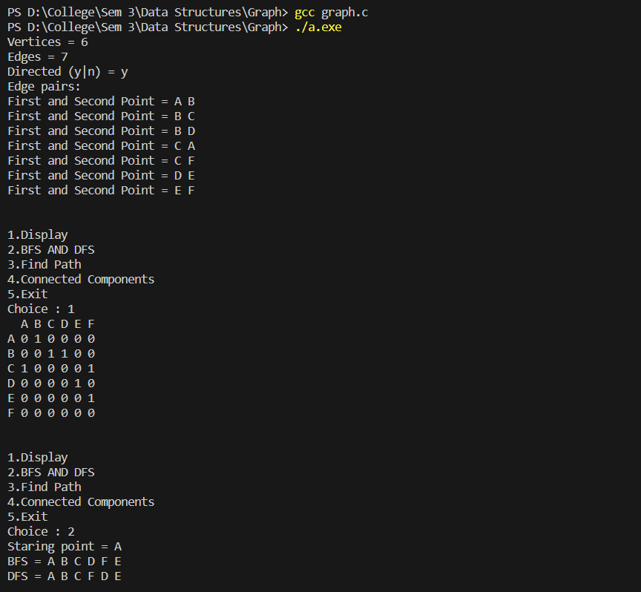

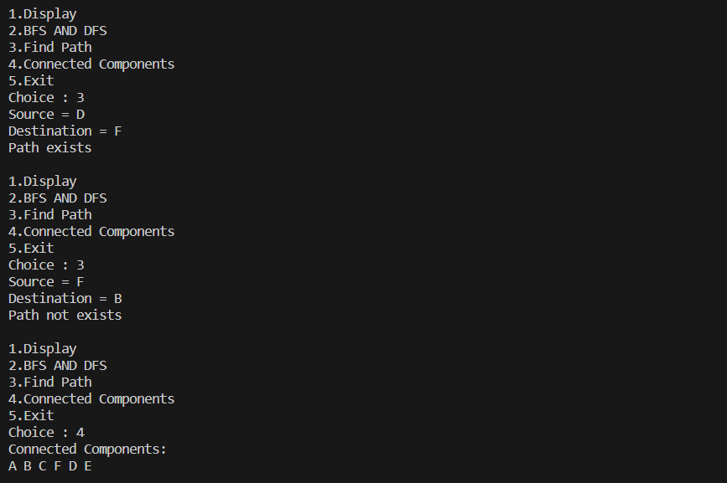

**Learning Outcome:**

